# Enabling Amazon GuardDuty

### Introduction

Amazon GuardDuty continuously monitors and identifies threats by analyzing several types of activity in your AWS account and any invited member accounts that you link. GuardDuty uses the following data sources to make its threat findings: VPC Flow Logs, AWS CloudTrail event logs, and DNS logs.

To start using GuardDuty, you must first enable it for your account. You will enable GuardDuty in this Lab Step. For this Lab, you will enable GuardDuty in a single AWS region. In practice, it is highly recommended that you enable GuardDuty in all supported AWS regions. This allows GuardDuty to generate findings of threats even in regions that you are not actively using.

### Instructions

1. In the upper-right corner of the AWS Management Console, click **Oregon** to open the region drop-down menu and click **US East (Ohio) us-east-2** to change the region:

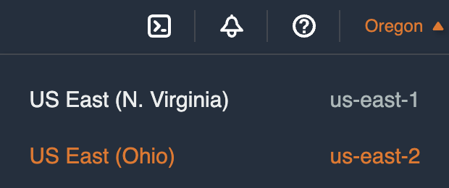

Your student user only has permission to use GuardDuty in the Ohio region.

2. In the AWS Management Console search bar, enter *GuardDuty*, and click the **GuardDuty** result under **Services**:

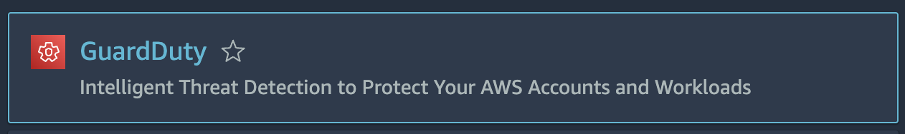

3. Click **Get Started** on the welcome page:

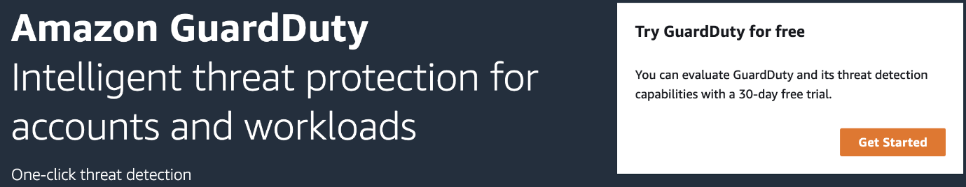

4. Click **Enable GuardDuty** to have GuardDuty start monitoring your AWS environment:

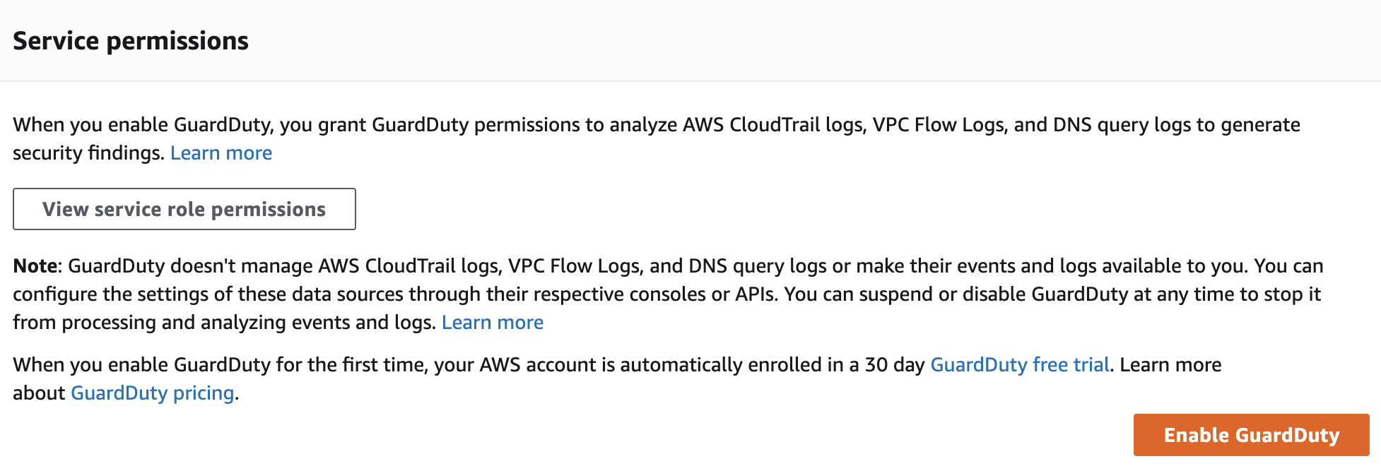

Enabling GuardDuty automatically creates a service-linked role to allow GuardDuty to gather metadata about EC2 instances in your environment. After you enable GuardDuty, it immediately begins pulling and analyzing streams of data from AWS CloudTrail, VPC Flow Logs, and DNS logs to generate security findings. This all happens automatically behind the scenes. For example, you do not need to create VPC Flow Logs to have GuardDuty monitor network activity in your VPCs.

### Summary

In this Lab Step, you enabled Amazon GuardDuty, so that security findings for your AWS environment can automatically be discovered.

VALIDATION CHECKS

**1Checks**

Check again

**Enabled GuardDuty**

Check if GuardDuty has been enabled.

Amazon GuardDuty